Install, Update and Remove Software for Windows

**Lab Introduction**

This lab will teach you how to perform basic software maintenance on Windows machines. This includes installing software that’s not already present on the machines, updating existing software to the newest version, and uninstalling software that‘s no longer needed. All of these tasks are very common in the IT world, so it’s important that you’re able to do them quickly and effectively.

**What you’ll do**

There are three learning objectives for this lab:

* **Install** - You’ll install the Mozilla Firefox web browser. There’s currently no version of Firefox on the machine you’ll be using, so it will be a fresh installation.
* **Update** - The machine you’ll be using comes preinstalled with an old version of the VLC Media Player. You’ll update VLC to the newest version.
* Uninstall - You’ll uninstall the GIMP photo-editing tool from the machine, removing it entirely.

**You will have 60 minutes to complete this lab.**

External IP address



username



password



# **Install, Update, and Remove Software in Windows**

**Introduction**

This lab will teach you how to perform basic software maintenance on Windows machines. This includes installing software that's not already present on the machines, updating existing software to the newest version, and uninstalling software that‘s no longer needed. All of these tasks are very common in the IT world, so it's important that you're able to do them quickly and effectively.

**Head's up**: You'll experience a delay as the labs initially load (particularly for Windows labs). So, please **wait a couple of minutes for the labs to load**. Please also make sure to access the labs **directly through Coursera** and not in the Qwiklabs catalog. If you access the labs through the Qwiklabs catalog, you will *not* receive a grade. (As you know, a passing grade is required to matriculate through the course.) The grade is calculated when the lab is complete, so be sure to hit "**End Lab**" when you're done!

You'll have 60 minutes to complete this lab.

What you'll do

There are three learning objectives for this lab:

* **Install**- You'll install the Mozilla Firefox web browser. There's currently no version of Firefox on the machine you'll be using, so it will be a fresh installation.
* **Update**- The machine you'll be using comes preinstalled with an old version of the VLC Media Player. You'll update VLC to the newest version.
* **Uninstall**- You'll uninstall the GIMP photo-editing tool from the machine, removing it entirely.

Verifying Windows configuration

The first steps of this lab will be to verify that the initial software setup, or "configuration," of programs on your machines is correct. These should already be set exactly as you'll need them, but it's important to know how to check for this information when working in an IT role.

You'll verify that Mozilla Firefox isn't installed on your Windows machine, and that both GIMP and version 2.2.8 of VLC Media Player are installed.

Start the lab

You'll need to start the lab before you can access the materials in the virtual machine OS. To do this, click the green “Start Lab” button at the top of the screen.

**Note:** For this lab you are going to access the **Windows VM** through your **local RDP Client**, and not use the **Google Console** (**Open GCP Console** button is not available for this lab).

Start Lab

After you click the “Start Lab” button, you will see all the connection details on the left-hand side of your screen. You should have a screen that looks like this:

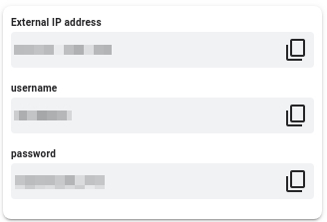

**Note:** Working with Qwiklabs may be similar to the work you'd perform as an IT Support Specialist; you'll be interfacing with a cutting-edge technology that requires multiple steps to access, and perhaps healthy doses of patience and persistence(!). You'll also be using **RDP** to enter the labs -- a critical skill in IT Support that you’ll be able to practice through the labs.

**Accessing the virtual machine**

Please find one of the four relevant options below based on your device's operating system.

Option 1: Windows Users: Connecting to your VM via RDP

In this section, you will use Remote Desktop Connection to connect to your windows instance using its external IP address.

1. Open Remote Desktop Connection by clicking the **Start** button. In the search box, type Remote Desktop Connection, and then, in the list of results, click Remote Desktop Connection.
2. Enter the external IP address of the instance you want to connect to in the **Computer** field. Find the external IP address for your instance from the Connection Details Panel on the left side. Click on **connect**.

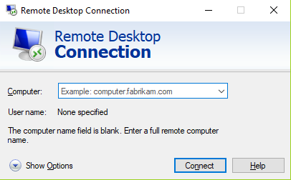

1. Change the username to **student**. And use the password mentioned in the Connection Details Panel on the left side. Click **OK**.
2. Click **Yes** to accept the certificate.

You should now see a visual interface that looks exactly like the Windows 10 OS!

If you see any error message, close the window and wait a minute or so. Sometimes the VM-creation process takes a few minutes, and you won't be able to access the VM until it's finished. This also applies to any errors that say your credentials (username and password) are incorrect.

Option 2: OS X users: Connecting to your VM via RDP

In this section, you will use Microsoft Remote Desktop 10 to connect to your windows instance using its external IP address. OSX users can [download Microsoft Remote Desktop from the Mac App Store](https://apps.apple.com/us/app/microsoft-remote-desktop-10/id1295203466?mt=12). If you are using Microsoft Remote Desktop 8, note that the interface will vary slightly than what’s listed below.

1. Open Microsoft Remote Desktop 10 application.
2. Click on **+** sign above, followed by **Add PC**.

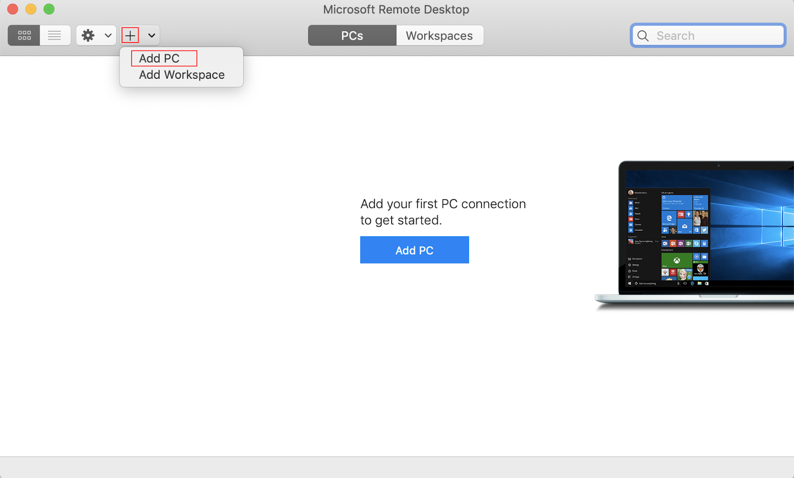

1. Enter the external IP address of the instance you want to connect to in the **PC name** field. Find the external IP address for your instance from the Connection Details Panel on the left side. Click on the **Add** button.

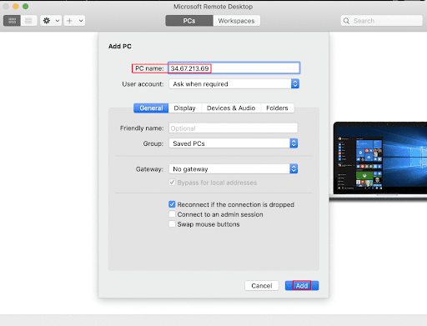

1. You should now be able to see your desktop represented by the external IP address of your VM instance under **PCs**. Double click on your VM’s external IP address.
2. The application will now prompt you for username and password. Change the username to **student**. And use the password mentioned in the Connection Details Panel on the left side. Once you have entered the details click **Continue**.
3. For any prompt regarding ‘Certificate verification’, click **continue**.

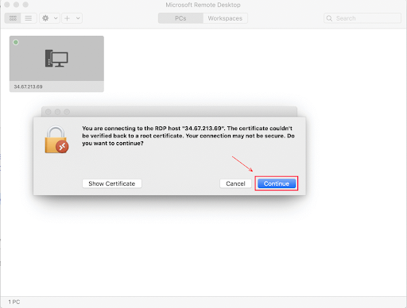

You should now see a visual interface that looks exactly like the Windows 10 OS!

If you see any error message, close the window and wait a minute or so. Sometimes the VM-creation process takes a few minutes, and you won't be able to access the VM until it's finished. This also applies to any errors that say your credentials (username and password) are incorrect.

Option 3: Chrome OS users: Connecting to your VM via RDP

In this section, you will use Chrome RDP to connect to your windows instance using its external IP address.

Chrome OS users can [download Chrome RDP from Chrome Web Store](https://chrome.google.com/webstore/detail/chrome-rdp/cbkkbcmdlboombapidmoeolnmdacpkch). Once you navigate to the download page, click on the **Add to Chrome** button. Click on **Add app** in case of any pop-ups. Then, click on **Launch app** to start the application.

1. Open the Chrome RDP application.
2. Enter the external IP address of the instance you want to connect to in the **Enter the computer name or address to connect to** field. Find the external IP address for your instance from the Connection Details Panel on the left side. Click on **connect**.
3. Leave the domain field blank. Change the username to **student**. And use the password mentioned in the Connection Details Panel on the left side. Click **OK**.
4. Click **Continue** for any window related to certificate verification.

You should now see a visual interface that looks exactly like the Windows 10 OS!

If you see any error message (an example of one is shown below), close RDP and wait a minute or so. Sometimes the VM-creation process takes a few minutes, and you won't be able to access the VM until it's finished. This also applies to any errors that say your credentials (username and password) are incorrect.

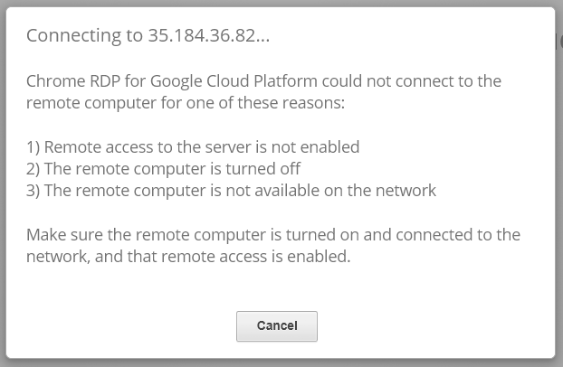

Option 4: Linux users: Connecting to your VM via RDP

In this section, you will use **Remmina** to connect to your windows instance using its external IP address. Open Remmina in your Linux machine. Linux users can [install Remmina](https://remmina.org/how-to-install-remmina/) if it is not pre-installed.

1. Open Remmina.
2. Enter the external IP address of the instance you want to connect to. Find the external IP address for your instance from the Connection Details Panel on the left side. Click on **Connect**.

Make sure the connection protocol is set to **RDP**, as shown in the image below:

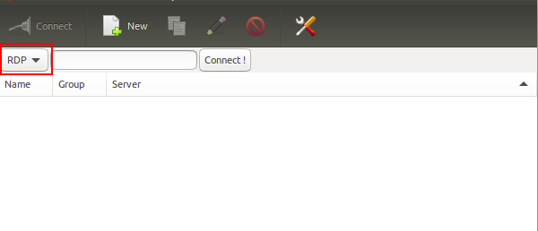

1. A window appears asking you accept the certificate, click **Ok** to continue.
2. Leave the domain field blank. Change the username to **student**. And use the password mentioned in the Connection Details Panel on the left side, for the **Password** field. Click **Ok** to continue.

You should now see a visual interface that looks exactly like the Windows 10 OS!

If you see any error message, close the window and wait a minute or so. Sometimes the VM-creation process takes a few minutes, and you won't be able to access the VM until it's finished. This also applies to any errors that say your credentials (username and password) are incorrect.

Using the Windows instance

Now you have access to the Windows instance, you're ready to start using it! This version of Windows is intended to be used on a Server, and auto-starts a server-management program. We don't need this for this lab, so wait for it to finish starting and then close it. You may see the desktop appear for a few seconds before the program launches.

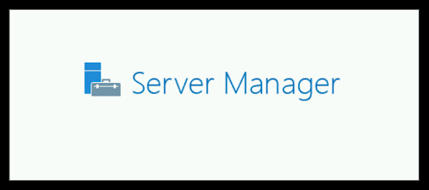 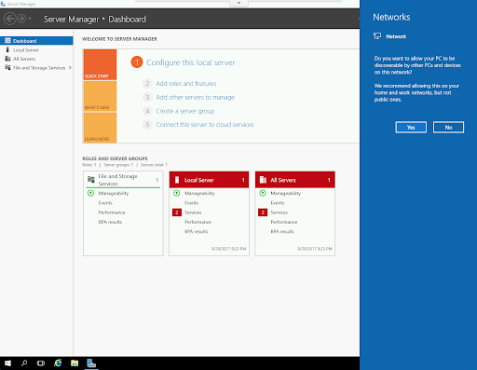

Once that's closed, the Windows OS is ready for you to use.

**Finishing the login process**

Now you‘ll see a Windows desktop background that looks like this:

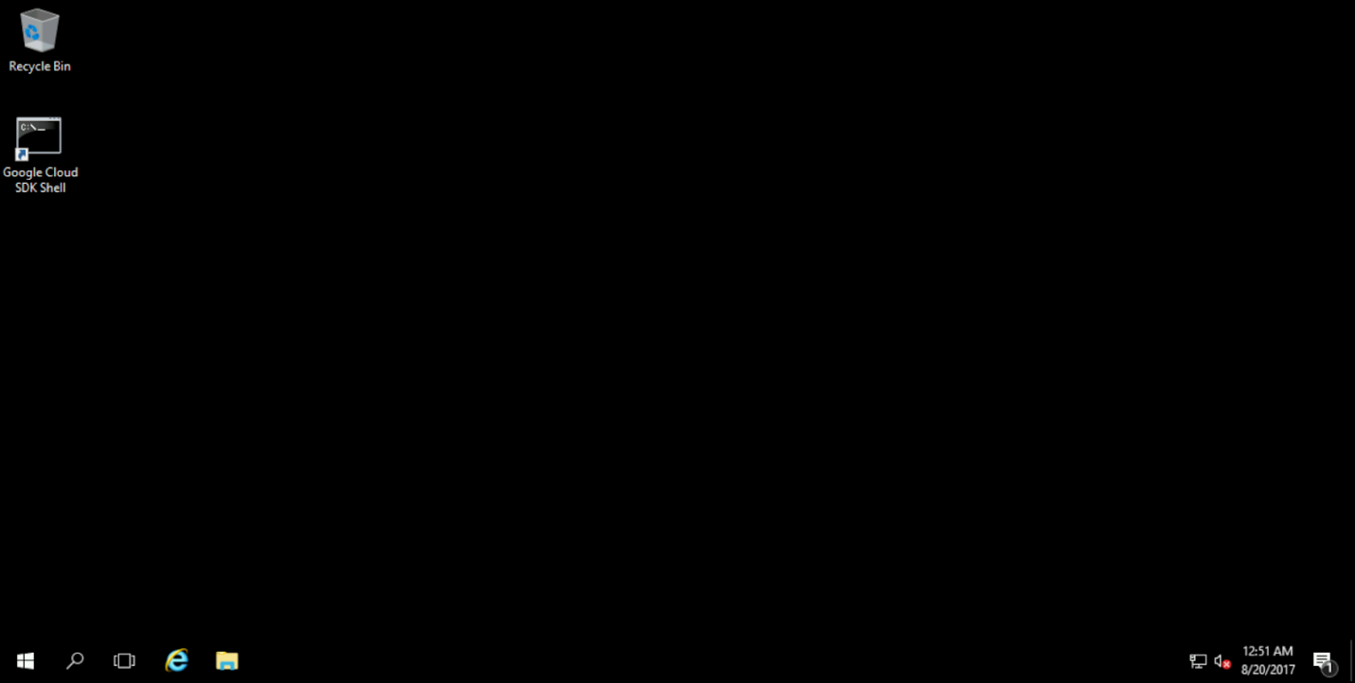

**Note**:

Please make sure that you have connected your RDP session with the username ‘student’ otherwise you will not earn the score for your lab objectives.

**Verifying initial setup on Windows**

To verify whether or not a program is installed in Windows, click the Start icon in the bottom-left of the taskbar, and start typing "Programs and Features" to search (as shown below). Then, click "Programs and Features." You can also right-click on the Start icon, and click on "Programs and Features" at the top of the menu.

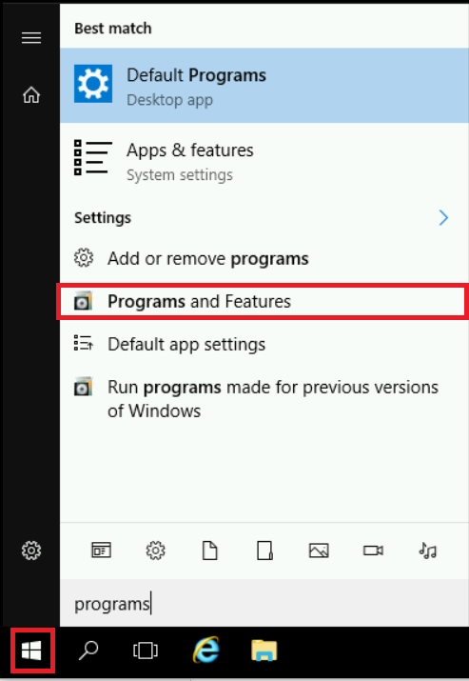

This will bring up the Programs and Features Control Panel applet, which shows a list of every program that's installed on the computer.

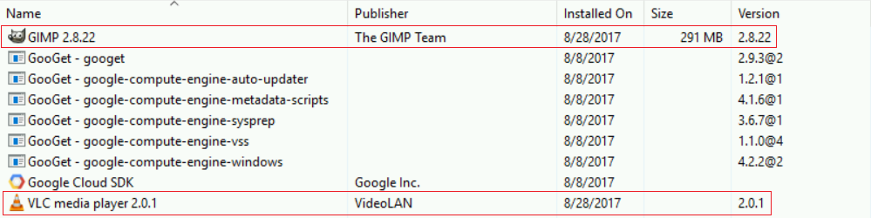

By looking at this applet, you can see that Mozilla software isn't present, so we know that it's not currently installed. Similarly, we can see that VLC and GIMP are both already installed, so we're ready to proceed. Note that the installed version of VLC is 2.2.8; this isn't the most recent version, so we'll update it later on in this lab.

**Maintaining software on Windows**

Now that we know that the Windows instance is properly configured (i.e. we have verified that Mozilla is not installed, but VLC and GIMP are both already installed), you can move on to the hands-on part of the lab; maintaining the software.

**Installing Mozilla Firefox**

First, you'll install the Mozilla Firefox browser in the Windows instance. To install Firefox, you need to download the Windows installer from the Firefox website. To do this, double-click the Google Chrome icon on the left side of the desktop screen, and navigate to this url:

<https://www.mozilla.org/en-US/firefox/new/>

From this site, click the "Download" link to download the installer.

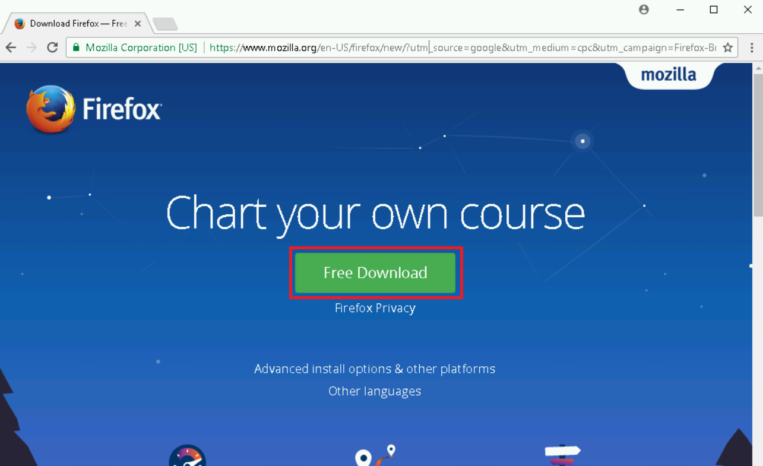

Once the installation finishes, click the installer icon in the bottom-left side of the browser window.

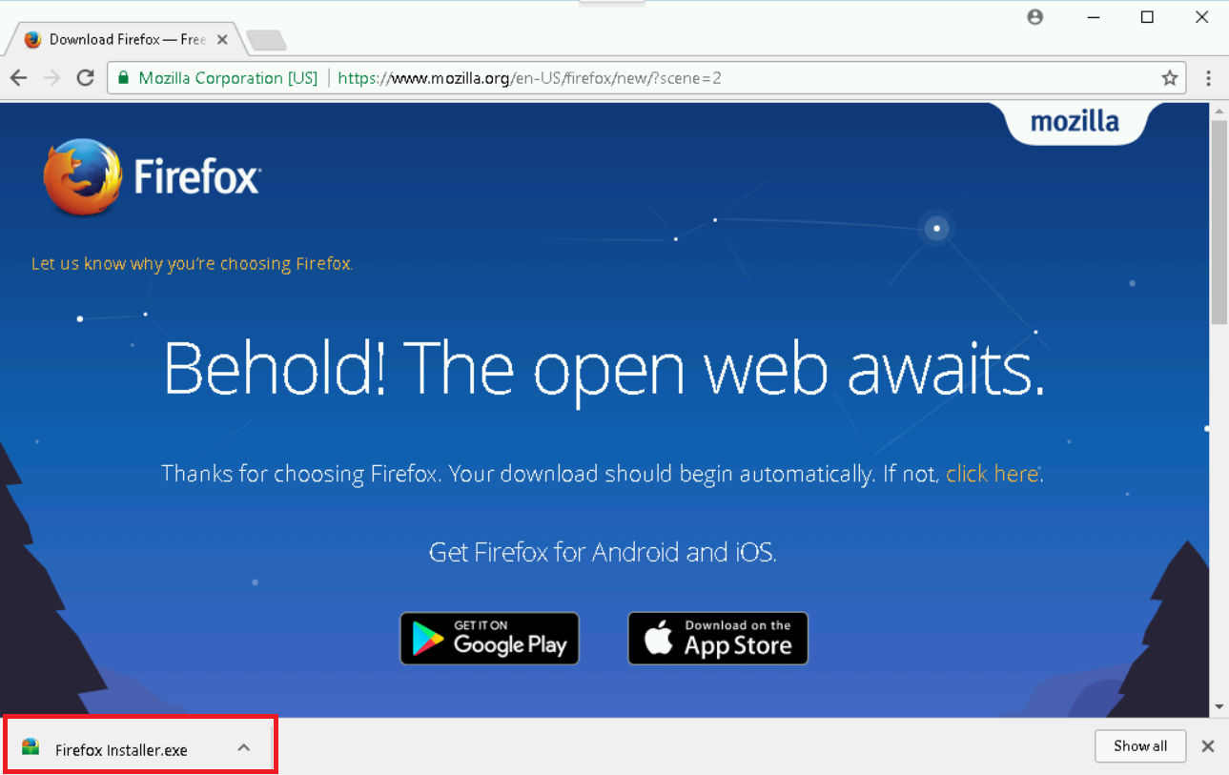

This launches the installer, and starts the installation process. Click "Yes" if Windows asks if you wish to install it, and the installer should open and begin.

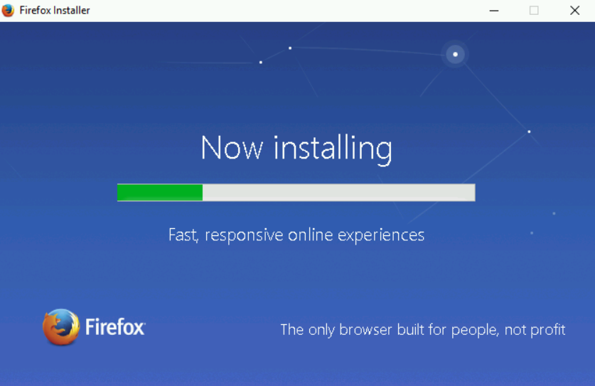

Click "Next" through any options that appear during the installation process. Wait for this process to finish, and Mozilla will be installed. A shortcut to Firefox will be added to the desktop, and you can double-click it to open your newly installed browser.

Congratulations! You've now done a "clean install" of software using Windows. Pretty simple, right? Next, you'll configure the updates for software already installed on your machine.

Click *Check my progress* to verify the objective.

Install Mozilla Firefox

Check my progress

**Updating VLC Media Player**

We saw before that an old version of VLC Media Player is already installed on the Windows VM we're using. This is an old version; we'll now learn how to update it in Windows. First, you need to get an installer for the new version from VLC's website. Open the link below to download the installer:

<https://www.videolan.org/vlc/download-windows.html>

Click on drop-down menu beside "Download VLC" and select "Installer for 64bit version" and wait for the installer to finish downloading.

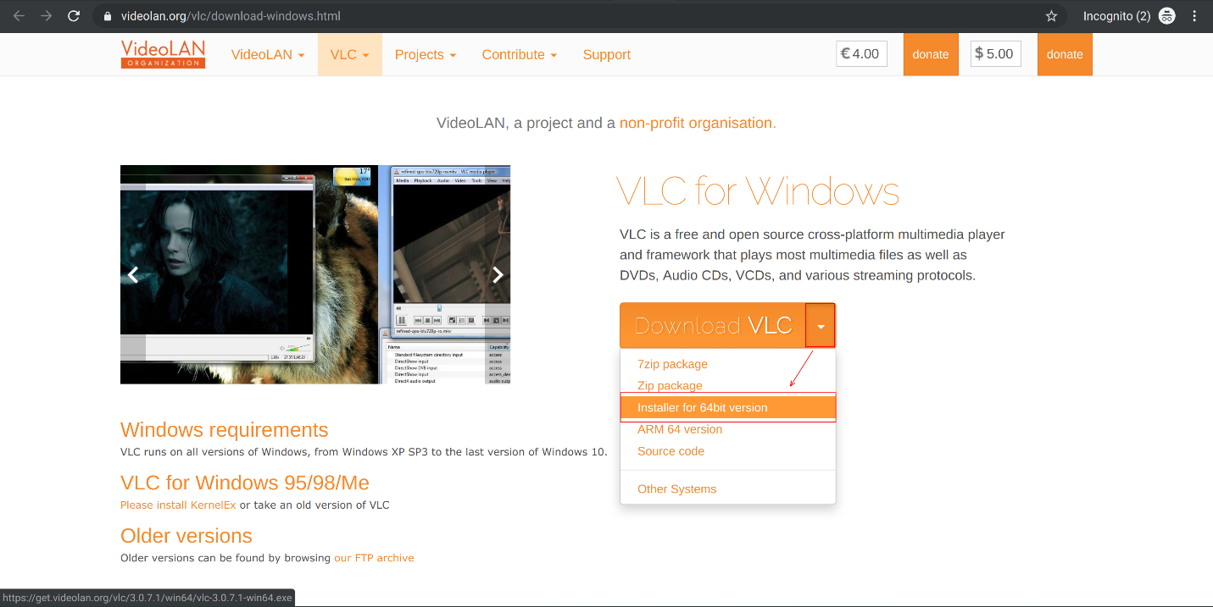

Once done, click on the installer to open it (like you did for Firefox).

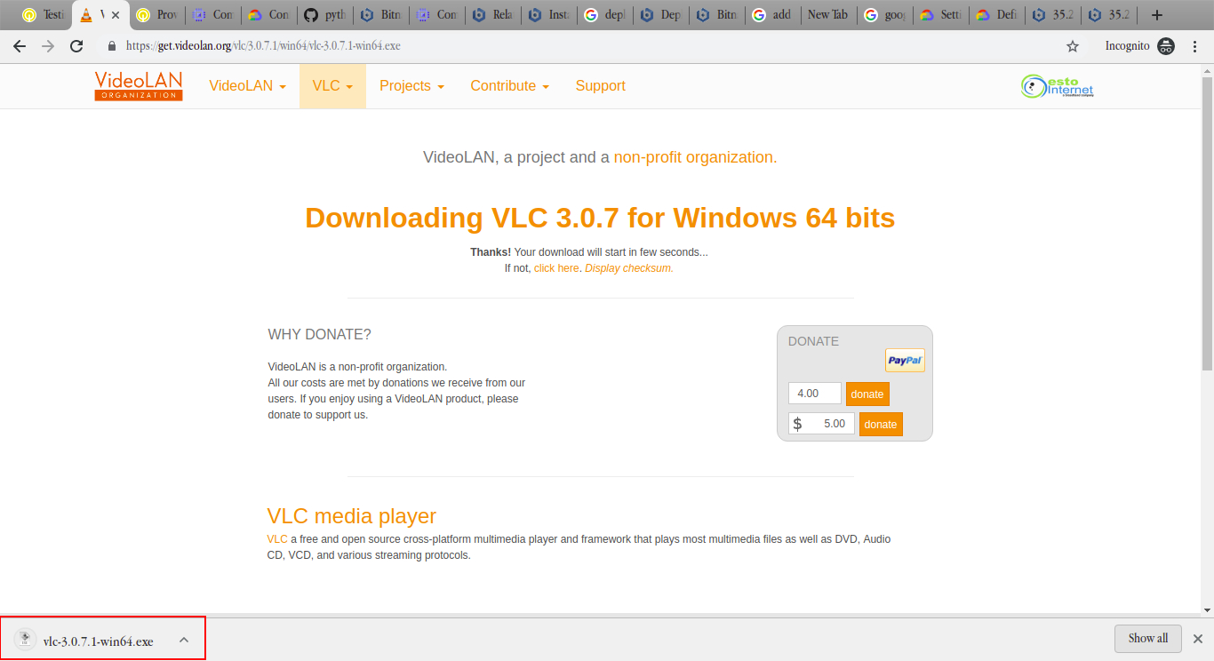

Once the installer opens, choose whichever language you're comfortable with, then click "Next" to begin the process.

Choose "Upgrade VLC using previous settings(recommended)" and then click "Next". A progress bar appears and the upgrade process begins.

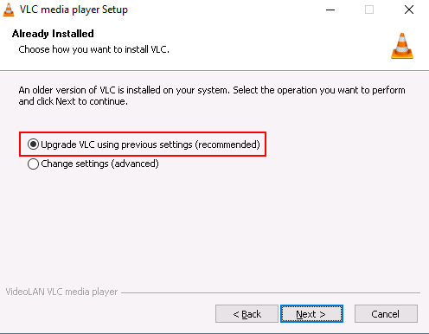

When the process is finished, a confirmation message will appear. Uncheck the option to run VLC, then click "Finish" to close the installer.

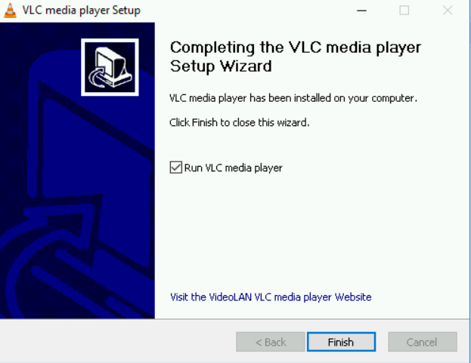

Reopen the "Programs and Features" window and you'll see that VLC is now at the latest version.

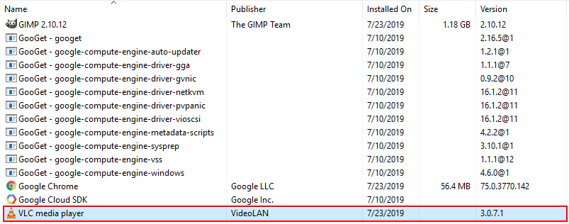

Click *Check my progress* to verify the objective.

Update VLC

Check my progress

**Uninstalling GIMP**

Uninstalling a program on Windows is super simple. Navigate back to "Programs and Features" and right click on the program you want to remove (i.e. GIMP). A single-item dropdown menu should appear:



Click on the "Uninstall" option in the dropdown. A confirmation menu will appear, asking if you're sure you want to proceed. Click "Yes" and the uninstallation process will begin.

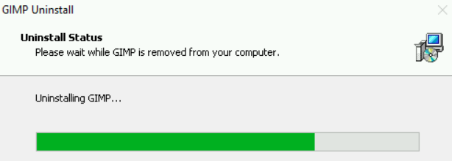

When this process finishes, a confirmation menu will appear. Clicking "OK" on that menu will close it, and GIMP should no longer appear on the list of installed programs. This completes the uninstallation process.

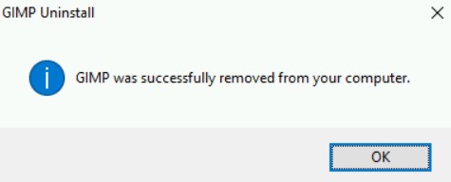

Click *Check my progress* to verify the objective.

Uninstall GIMP

Check my progress

**Congratulations!**

You've successfully installed Firefox, updated VLC, and uninstalled GIMP on a Windows machine. Wohoo! You've completed this lab, but please feel free to return to it if you ever need a refresher.